Hive task 15.1

Calculate the number of employees corresponding to each skill from the table 'employee' which is loaded in the Demo.

Select skill,COUNT(name) from emp_details Group By skill;

This is the output:

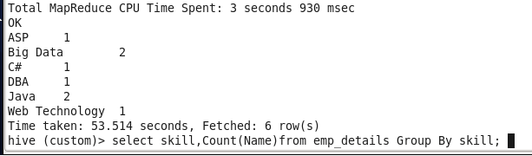

Input data is :

